

Celestina

Claudia Rubio

Version: 1.0

Overview

Celestina is a platformer precision game inspired by the game Celeste. In this game Madelina the player character has to climb to the top of the mountain by jumping through platforms and avoiding obstacles.

Game Description

Objective: The objective of the game is to beat all the levels. Each level has its own theme and difficulty.

Gameplay: The player starts with the tutorial level where they learn about the basic interactions between objects and the character. In this level they get experience in turning off and on switches that turn fire balls into ice balls and vice versa, jumping on trampolines, jumping on moving ice balls, avoiding spikes, and reaching the flag marking the end of the level. These concepts are applied over the remaining three levels. Like any platformer game, each level consists of different arrangement of objects the player interacts with.

Controls: Left and right arrow key move the player horizontally and the space bar make the player jump as long as the character is on the ground.

Assets Used

* All images were drawn by me using <https://www.piskelapp.com/>
  + Objects

* + Character: 16 similar versions facing left and 16 similar versions facing right that loop and make the character look animated as if it is walking, moving hands and legs.

* + Backgrounds: (there are 15 different versions of the first background that make clouds look as if they are moving)

* + Tutorial Level guide

* Sound files:
  + Minecraft Glass Breaking Sound (used for sound effect when clicking buttons and the player dying) <https://www.youtube.com/watch?v=NemrdQNeeyg>
  + Celeste Original Soundtrack – First Steps (background music) <https://www.youtube.com/watch?v=N8OHSXvneOE>

User Menu

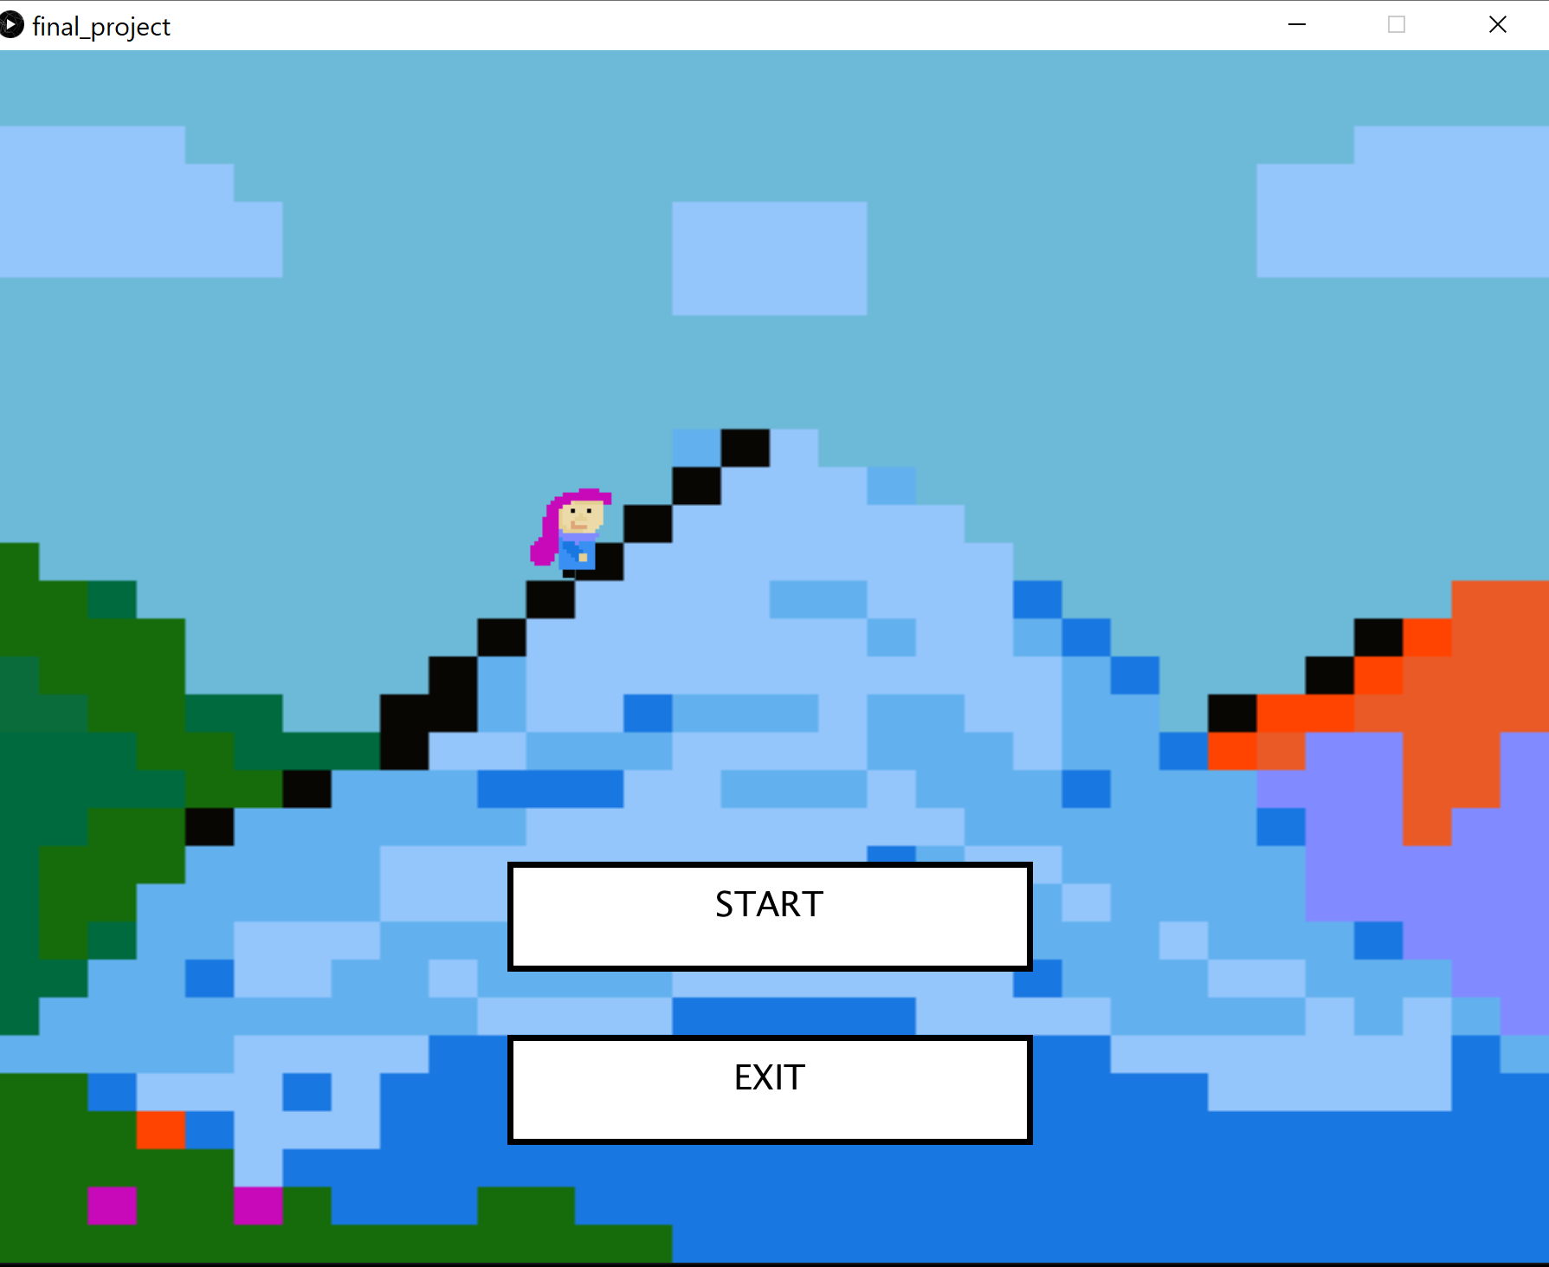 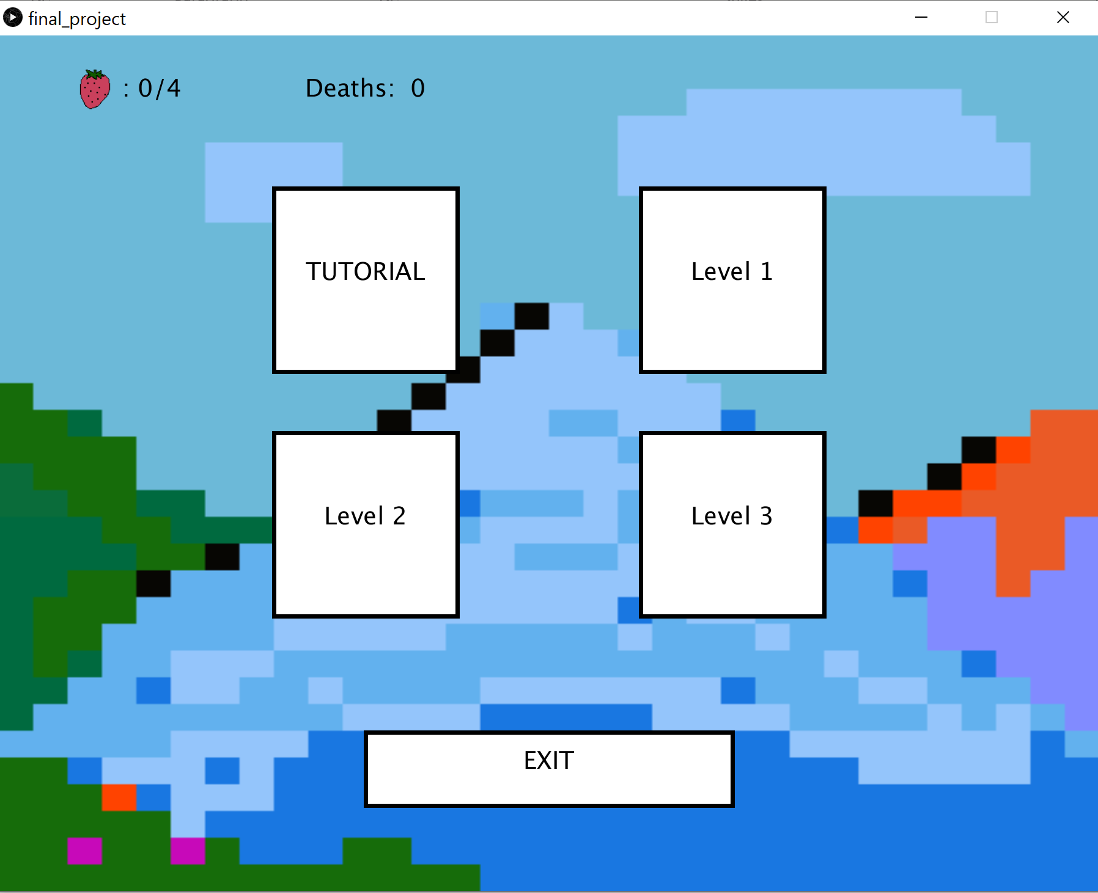

First, the player opens the games and has the option to choose a level to play from the initial menu. The left and right arrow keys are used to move the player character horizontally and the space bar to give it vertical velocity. At any moment during a level, the player can go back to the user menu where you can choose another level, see completed levels, number of deaths and number of collected strawberries. There’s also an exit button.

There are 2 main type of obstacles: Fire balls and spikes. Both of these objects will send the character to the start of the level if the character collides with them. Fire balls are able to move while spikes will always remain in place. Landing on a trampoline will give players a big jump while jumping on ice balls give players just a small bounce. Ice balls are able to move while trampolines will remain in place. Switches will turn ice balls into fire balls and vice versa if the player collides with the switch. Platforms in the air are a safe place for the player to stand. Flags mark the end of the level and once the player reaches a flag, the level is completed. When a level is beat a screen shows congratulating the player and asking if the player wants to continue to the next level or go back to the user menu. There’s one collectible strawberry is available in each level. They are supposed to present a challenge to the player since they will be hard to get but they are not necessary to beat the level.

